С помощью электронных компонентов и языков программирования Arduino и Java разработать программно-аппаратный комплекс умной настольной светодиодной лампы. 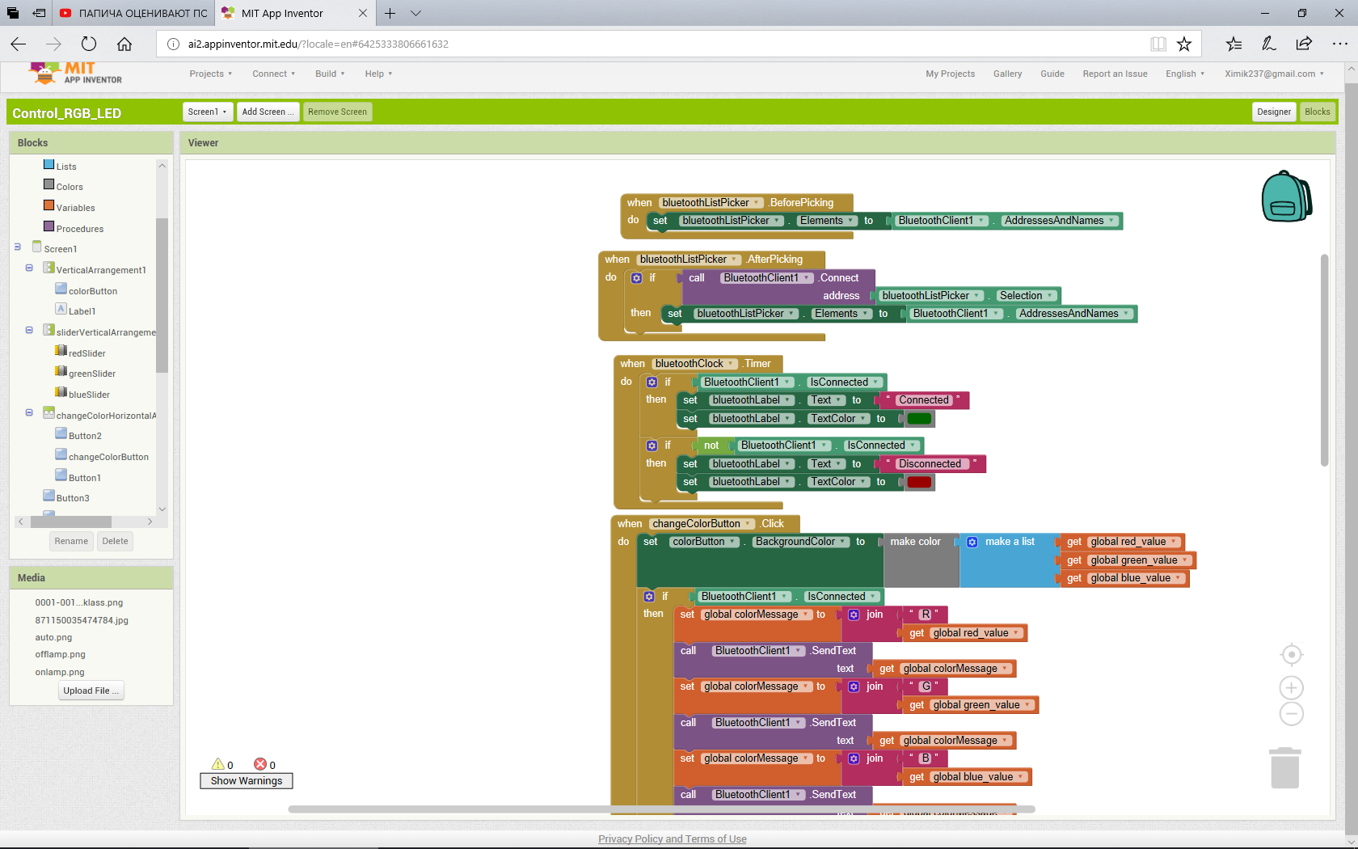

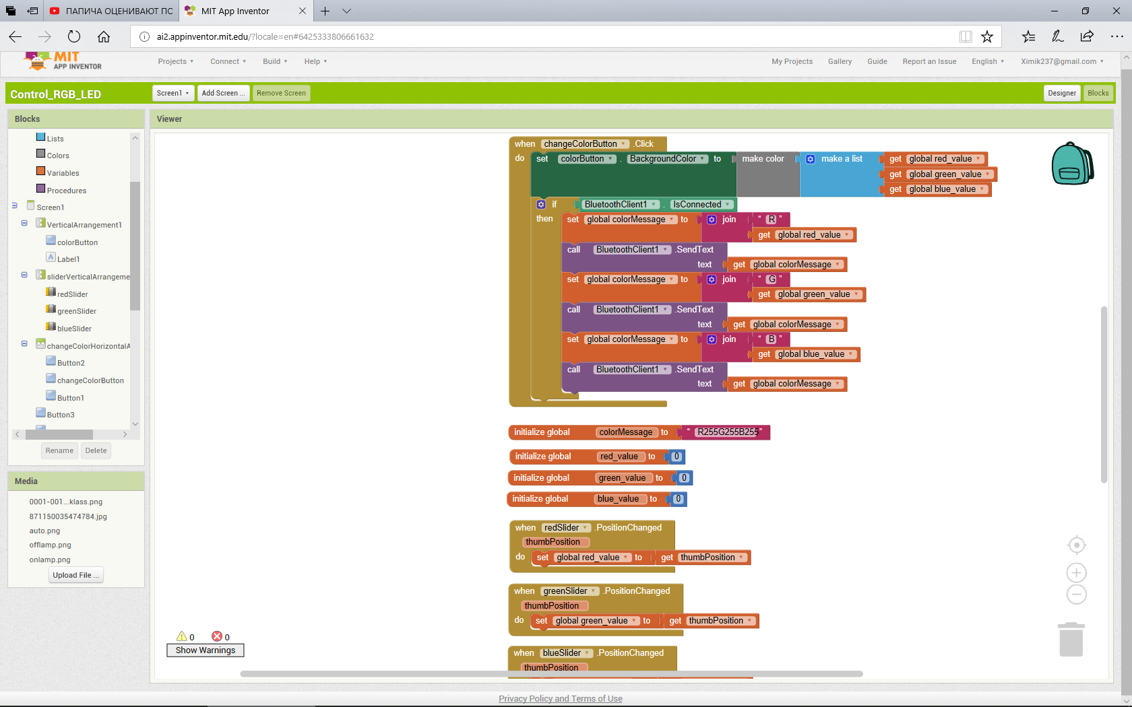

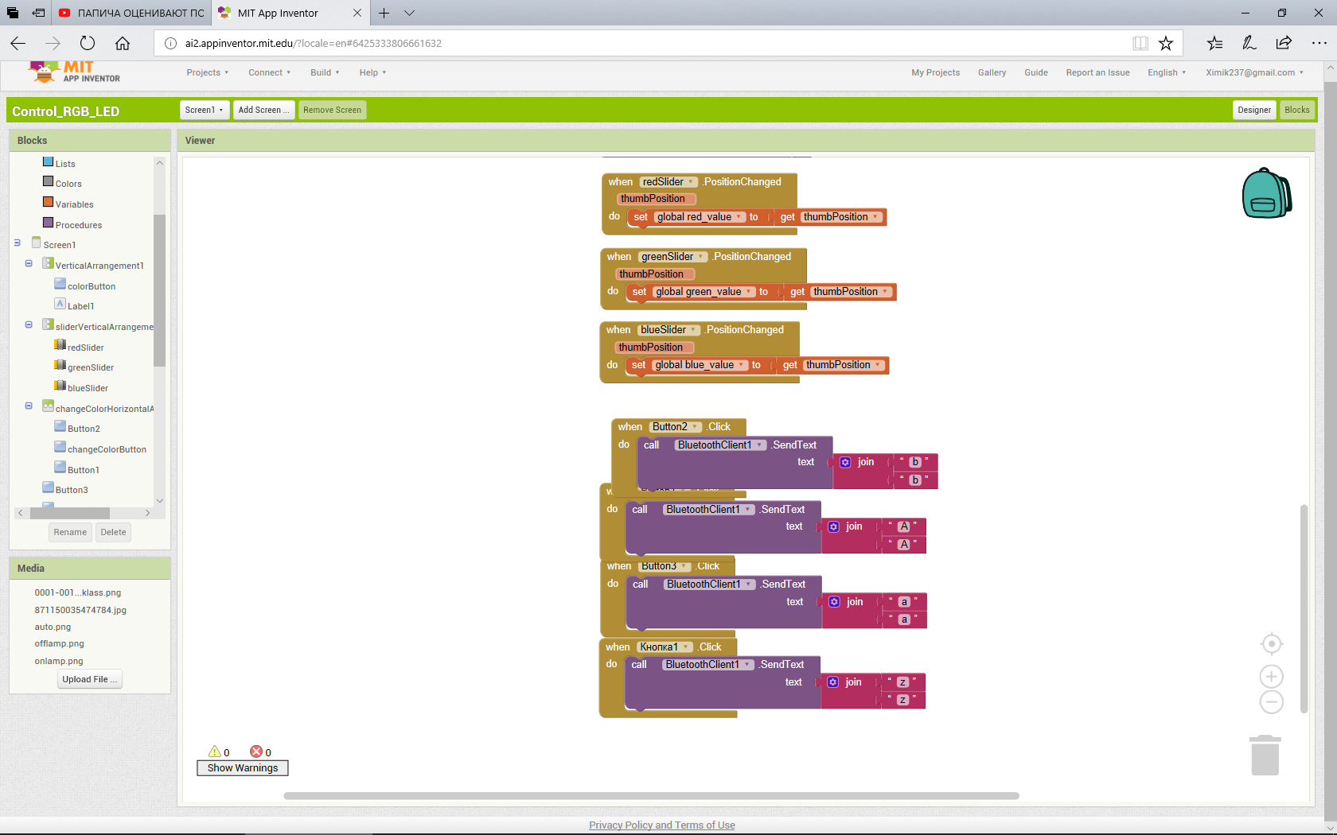

Код программы Arduino IDE

#define max_char 12

char message[max_char];

char r_char;

byte index = 0;

int i;

int b = 0;

int b1 = 0;

int b2 = 0;

int redPin = 9;

int greenPin = 10;

int bluePin = 11;

int redValue = 255;

int greenValue = 255;

int blueValue = 255;

int val='a';

String redTempValue;

String greenTempValue;

String blueTempValue;

int flag = 0;

char currentColor;

void setup() {

pinMode(redPin,OUTPUT);

pinMode(bluePin,OUTPUT);

pinMode(greenPin, OUTPUT);

Serial.begin(9600);

}

void loop() {

while(Serial.available() > 0)

{

val = Serial.read();

switch(val)

{

case 'a':

{

while(val == 'a')

{

int sensorValue = analogRead(A0);

sensorValue = constrain(sensorValue, 4, 200);

int ledLevel = map(sensorValue, 4, 200, 255, 0);

analogWrite(bluePin,ledLevel);

analogWrite(greenPin,ledLevel);

analogWrite(redPin,ledLevel);

if (Serial.read()== 'A')

{break;

}

}}

case 'A':

{

analogWrite(bluePin, b);

analogWrite(greenPin, b1);

analogWrite(redPin, b2);

b = b2 = b1 = 0;

break;

}

case 'b':

{

analogWrite(bluePin, b);

analogWrite(greenPin, b1);

analogWrite(redPin, b2);

b = b2 = b1 = 255;break;

}

case 'z':

{

while(val == 'z')

{

while(Serial.available() > 0)

{

flag = 0;

if(index < (max_char-1)){

r_char = Serial.read();

message[index] = r_char;

if(r_char=='R'){

currentColor = 'R';

redTempValue = "";

}

else if(r_char=='G'){

currentColor = 'G';

greenTempValue = "";

}

else if(r_char=='B'){

currentColor = 'B';

blueTempValue = "";

}

if(currentColor == 'R' && r_char!='R'){

redTempValue += r_char;

}

else if(currentColor == 'G' && r_char!='G'){

greenTempValue += r_char;

}

else if(currentColor == 'B' && r_char!='B'){

blueTempValue += r_char;

}

index++;

message[index] = '\0';

}}

if(flag == 0){

analogWrite(redPin, 255-redTempValue.toInt());

analogWrite(greenPin, 255-greenTempValue.toInt());

analogWrite(bluePin, 255-blueTempValue.toInt());

Serial.println(message);

flag=1;

for(i=0; i<12; i++){

message[i] = '\0';

}

index=0;

}

if (Serial.read()== 'A')

{break;

}

}

}

}

}

}